Open ID tech Proposal:

Open ID is a decentralized means of authenticating users by using a third party ID provider. URIs serve as user identifiers, each OpenID provider has their own methods for verifying the authentication of its users. The Parties involved in and OpenID scheme are the user, ID provider where the user validates her or his identity and the Relying party or consumer site utilizing the open ID service to provide authentication services.

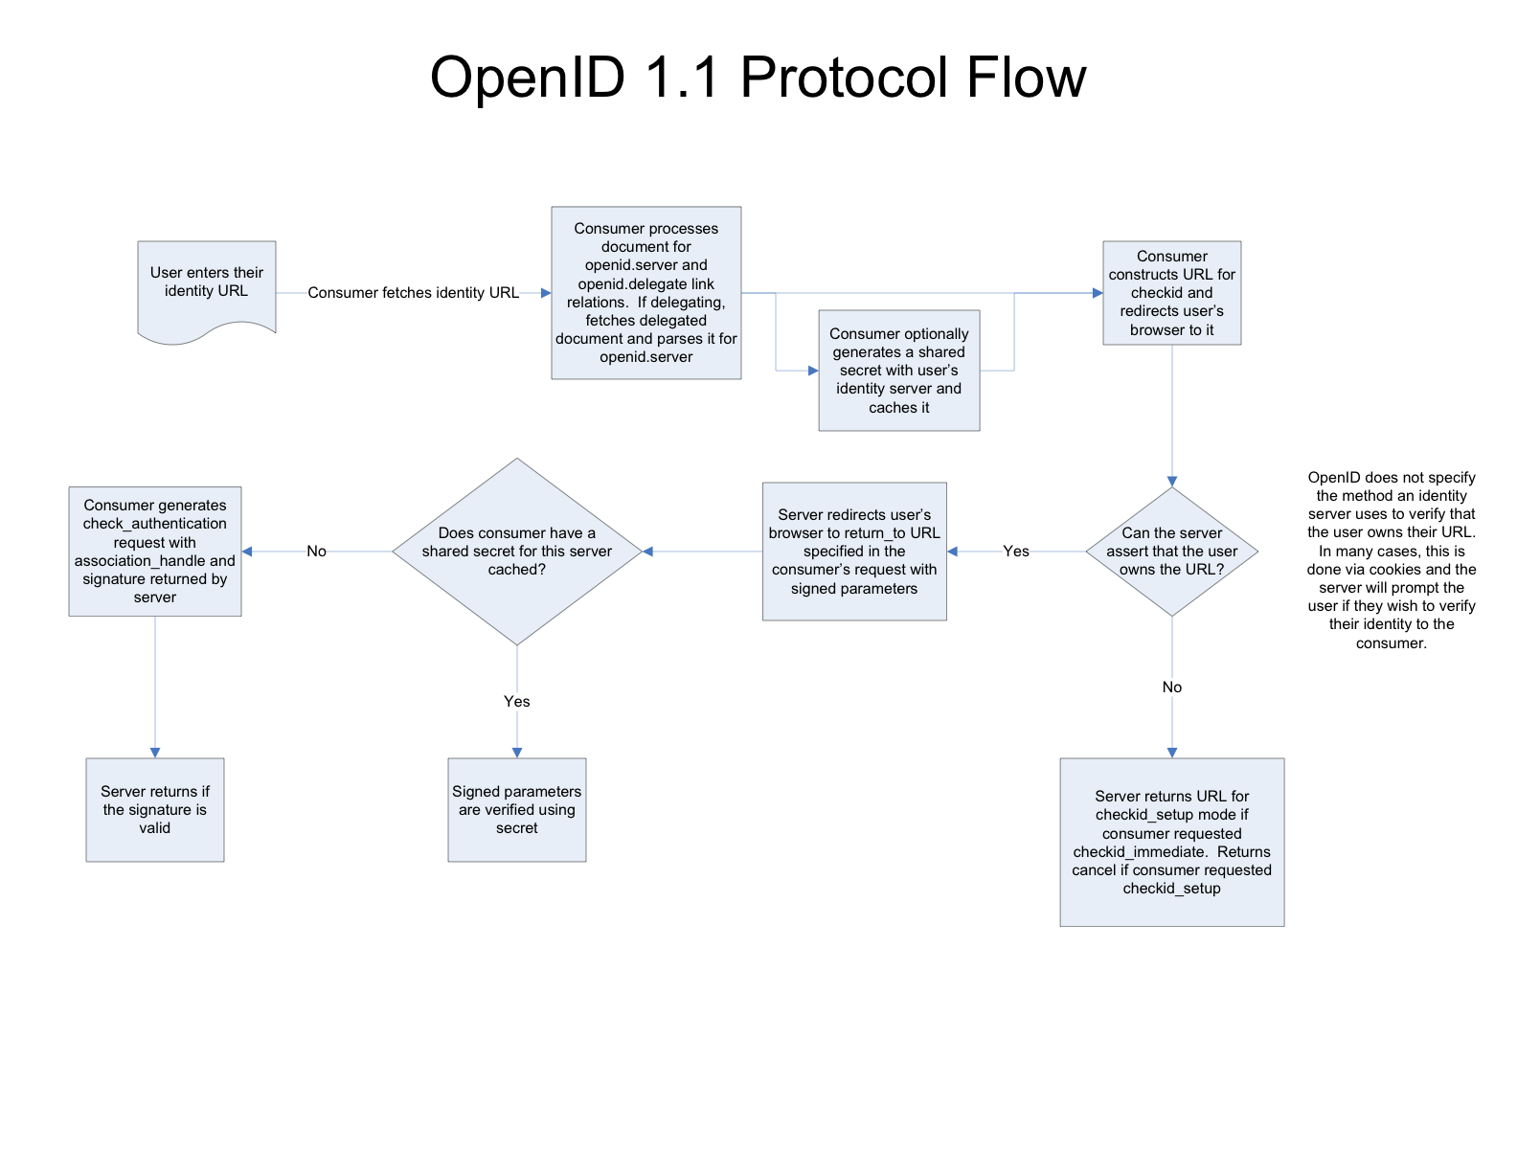

Figure OpenID 1.1 protocol flow. http://openid.net/pres/protocolflow-1.1.pnghttp://openid.net/pres/protocolflow-1.1.png

The advantage of OpenID has been described by its creators at OpenID.net as “OpenID is a safe, faster and easier way to log into websites”. These advantages benefit the users and the consumer of OpenID services. OpenID safety allows the users to enter their credentials in one place, on their OpenID site of their choosing. OpenID can be faster for users by utilizing demographic information used on the OpenID provider’s site to fill form information and ease website registration. Auto population of registration forms is one way in which OpenID can be easier for users, while also for updates of maintenance of user information on one site, the OpenID provider’s site. OpenID also beings benefits for the consume rsite by offloading support of password resets and some logon issues to the OpenID providers. Consumer sites utilizing OpenID may have greater follow through with user registration given the ease and speed increases in use of OpenID.

Our implementation of OpenID can utilize the authentication functions of OpenID for registration or to view events. Demographic information can be imported from the OpenID providers to provide contract information and location.